OES Project Design Document
Author: Leif Liu
Last Updated: 2017-11-07

Executive Summary if applicable
A short description of what this design document entails. The ‘what’ part of the design is of main interest in this section.
Document History
Date | Author | Summary of Change | Note
2017-11-07 | Leif Liu | Initialized version.
<Table of Contents>

Overview 4
High Level Architecture 4
Detail Design 4
Class Diagram 4
Sequence Diagram 4
Entities and Relationship 5
Detail Database Schema 6
Table Name01 6
Interface Definitions 6
APIs/Interfaces 7
User Interfaces 7
Error and Exception Handling 7
Other Design Considerations 7

Overview
We suppose to implement an online exam system which helps students take the exam and teachers review the exam results. The user with SysAdmin role can manage all users including create/edit/delete user. The user with ContentAdmin role can manage questions and create exam. Each user can access this system to edit his personal profile.

High Level Architecture
How does this project (or piece of software) fit into the entire system? What role does this project play in relation to the environment in which this project is to function? Again, paying attention to the “what” part of the functionality, what does the overall architecture look like?

Detail Design

Class Diagram
List all class diagrams into here. <Draw diagram tool: Jude or its latest version Astah>
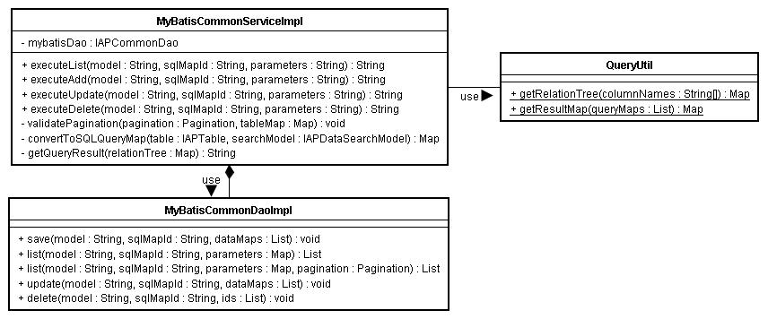

Sequence Diagram
List all sequence diagrams into here and give brief description. <Draw diagram tool: Jude or its latest version Astah>

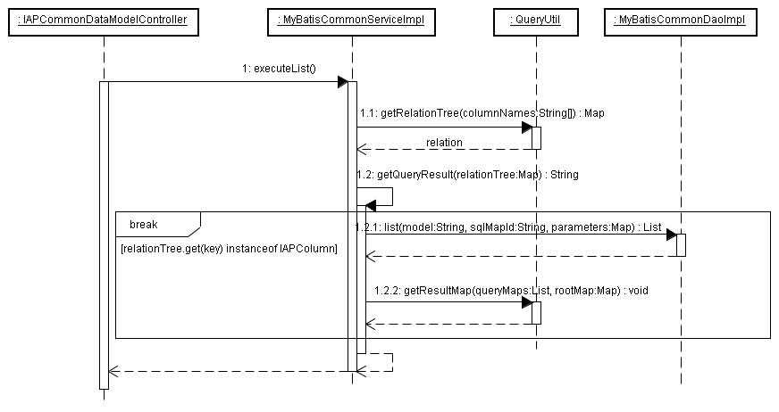

Entities and Relationship
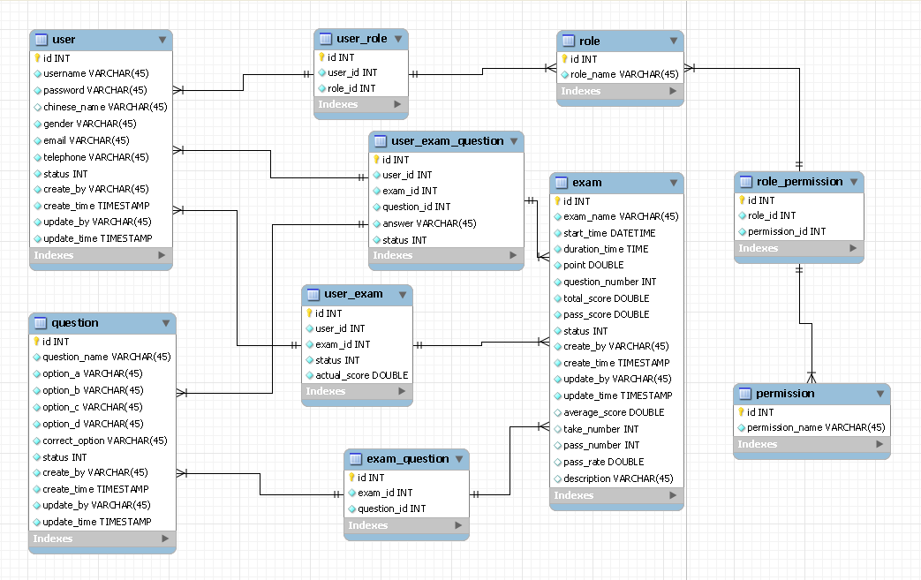

Detail Database Schema

user
Field Name | Data Type | Size | Null? | Comment
id | Int | default | No | Primary key
username | varchar | 45 | No
password | varchar | 45 | No
chinese_name | varchar | 45 | Yes
gender | varchar | 45 | No
email | varchar | 45 | No
telephone | varchar | 45 | No
status | int | default | No | 0: illegal user; 1: legal user
create_by | varchar | 45 | No
create_time | timestamp | default | No
update_by | varchar | 45 | No
update_time | timestamp | default | No

role
Field Name | Data Type | Size | Null? | Comment
id | Int | default | No | Primary key
role_name | varchar | 45 | No

user_role
Field Name | Data Type | Size | Null? | Comment
id | Int | default | No | Primary key
user_id | Int | default | No | Foreign key of user
role_id | Int | default | No | Foreign key of role

permission
Field Name | Data Type | Size | Null? | Comment
id | Int | default | No | Primary key
permission_name | varchar | 45 | No

role_permission
Field Name | Data Type | Size | Null? | Comment
id | Int | default | No | Primary key
role_id | Int | default | No | Foreign key of role
permission_id | Int | default | No | Foreign key of permission

exam
Field Name | Data Type | Size | Null? | Comment
id | Int | default | No | Primary key
exam_name | varchar | 45 | No
start_time | datetime | default | No
duration_time | time | default | No
point | double | default | No
question_number | int | default | No
total_score | double | default | No
pass_score | double | default | No
status | int | default | No | 0: not started; 1: in progress; 2: ended
create_by | varchar | 45 | No
create_time | timestamp | default | No
update_by | varchar | 45 | No
update_time | timestamp | default | No
average_score | double | default | Yes
take_number | int | default | Yes
pass_nubmer | int | default | Yes
pass_rate | double | default | Yes
description | varchar | 45 | Yes

user_exam
Field Name | Data Type | Size | Null? | Comment
id | Int | default | No | Primary key
user_id | Int | default | No | Foreign key of user
exam_id | Int | default | No | Foreign key of role
status | Int | default | No | 0: not passed; 1: passed
actual_score | double | default | No

question
Field Name | Data Type | Size | Null? | Comment
id | Int | default | No | Primary key
question_name | varchar | 45 | No
option_a | datetime | default | No
option_b | time | default | No
option_c | double | default | No
option_d | int | default | No
correct_option | double | default | No
status | int | default | No | 0: can't be selected; 1: can be selected
create_by | varchar | 45 | No
create_time | timestamp | default | No
update_by | varchar | 45 | No
update_time | timestamp | default | No

exam_question
Field Name | Data Type | Size | Null? | Comment
id | Int | default | No | Primary key
exam_id | Int | default | No | Foreign key of exam
question_id | Int | default | No | Foreign key of question

user_exam_question
Field Name | Data Type | Size | Null? | Comment
id | Int | default | No | Primary key
user_id | Int | default | No | Foreign key of user
exam_id | Int | default | No | Foreign key of exam
question_id | Int | default | No | Foreign key of question
answer | varchar | 45 | No
status | int | default | No | 0: the answer is false; 1: the answer is true; 2: the answer is null

Interface Definitions
If this project delivers a set of APIs or interfaces, then this section describes what they are.

APIs/Interfaces
Name of the APIs or interfaces being developed and delivered to end users.
Name and description of the methods in each interface.

Each API/Interface should have unique ID for cross reference purposes (FSI0001, FSI0002, etc.)

User Interfaces
Please refer to formal User Interface Specification Template.

Error and Exception Handling
What is the behavior of features under error conditions?
What feedback mechanisms of error condition does the feature have?

In case end users are software developers who are embedding this component, also use this section to identify errors and exceptions that his component generates for the downstream error handling routines.

Other Design Considerations
You can add other design considerations into here. For example, consider to contribute public component into company standard component repository, consider to open source part of code, consider to use exist standard component, etc.

